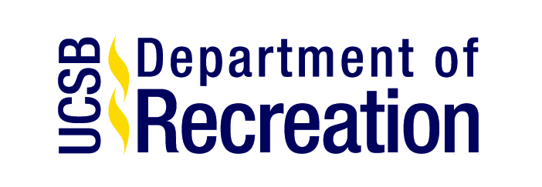
March 21, 2018

Dear UCSB Students, Staff, Faculty, Alumni and Community,

The time has finally come to slip on your softball gloves, lace up your cleats, and step into the batter’s box! You are cordially invited to participate in this year’s 36th Annual UCSB Student-Alumni One-Pitch Softball Tournament. This year’s tournament will take place on Saturday, April 28th, 2017 (during All Gaucho Alumni Weekend) on Storke Field, right across from Harder Stadium.

This one-day tournament will tip off at 9am Saturday morning and a champion will be crowned by 3pm. The registration fee will be $200 per alumni team and FREE for student teams, which will include t-shirts and light breakfast refreshments at the field. Your registration forms are available to down load.

Registration forms are due no later than Tuesday April 24th, 2018.

How to register:

- You can register online at https://register.recreation.ucsb.edu (listed under events) and email your Registration Form and Roster to Ashley.Marsh@recreation.ucsb.edu

- You can pay at the Recreation Center Customer Service and drop off your Registration From and Roster to the Recreational Sports Office (at the UCSB Recreation Center in Room 1110)

- You can mail in your payment in the form of a check (to: UC Regents) along with your Registration From and Roster to:

Att: Ashley Marsh/Alumni Softball Tournament
Department of Recreation
1509 Recreation Center
University of California Santa Barbara
Santa Barbara, California 93106-3025

We hope you will participate in this once a year Recreational Sports tradition. If you have any questions, feel free to contact us at (805) 893-3913, or through e-mail at Ashley.Marsh@recreation.ucsb.edu. We look forward from hearing from you!

Sincerely,

Ashley Marsh
Events and Summer Camps Coordinator
Recreation Department
University of California, Santa Barbara
805-893-3913

